# Web & Database Computing Group Project – Part 1

## Introduction

The project requirements are to have the following:

* Users should be able to sign up and log in to make or manage hotel bookings and manage their information
* Hotels should be able to sign up and log in to manage (i.e. add/delete/update) rooms and hotel information
* Users should be able to search for rooms by location and booking date
* Users should be able to view a map of the location containing markers for each of the hotels listed
* Users should be able to view additional information about hotels by interacting with the map
* Users should be able to leave a review after their booking
* Users should be able to link a social media/email/other account to login with that provider (OpenID), but must be able to login without one

The research of existing websites will be focused around these project requirements. The style, structure and features of these webpages will be critiqued. This critique will help build our groups website in the future.

The websites which will be researched will mostly come from reputable hotel chains. They obviously have enough money so that their websites will be probably be of a high standard. Other websites sound be newer businesses such as Airbnb, etc because they might be savvier.

## Hotel Research

### Airbnb

The core pages of Airbnb are:

* The home page
* Sign up page
* Log in page
* Searching page
* Room page

#### Style

The style of the webpage is minimalistic. White backgrounds with grey/black coloured font. Which is an excellent contrast to the pictures of locations and rooms that are presented on the webpage. This contrast is used to draw user attention to the ‘important’ parts of the webpage. It also reduces cognitive load on the use by reducing the visual stimulus from the webpage.

#### Structure

The home page only used the middle 1/3rd column of the webpage. This must make using the homepage on phone or tablet device easier, because they effectively operate using columns.

The sign up page and log in page are structures very similarly. The essential information is placed in the middle 1/3rd column of the webpage so that the fields are ‘unmissable’ and simple to navigate. This reduces the cognitive load of the user, because they either focus on the header or the middle column of pages.

#### Features

One strange features is the header. The header contains the core information of the webpage. And it is fixed to the top of the webpage when the user is scrolling down, thus this eases cognitive and kinetic load on the user. The issue is that when a room is selected the header is no longer fixed, this is probably used to make it more difficult for the user to direct themselves away from the webpage due to business reasons.

The search on the front page only has a location field. But on the search page it has additional filters which makes searching for rooms less cognitively exhausting for the user because they do not need to browse as much.

The search/browse page also has an interactive map with the location of rooms, on a Google Map. This is own of the core requirements for our own webpages.

When browsing through rooms, the pictures of the rooms can be scrolled through by clicking the left and right arrow. This maximises the amount of information provided by the website, whilst also reducing kinetic load on the user.

### Trivago

#### Style

Instead of a pure white background it is somewhat pearly or light gray. Text is normally black, and important text are different colours. For example, savings text are coloured text, review scores are colour coded based on the score and the looking for deals button is coloured. This highlights to the used the important information.

#### Structure

The search page is better structured compared to Airbnb. There are filter options on the left column of the page, it also contains a link to interactive Google Map. This makes the google map non-invasive on the search webpage, and it also allows the user the power to control the size of the map, since it then covers the whole webpage.

Browsing through hotels is easier, it drops down the relevant information. This also makes it to close the drop down, and continue browsing. From a cognitive point of view, it means the user, just continues to scroll down. It also has features which will enable the user to scroll to the ‘top’ where they can then organise their booking.

#### Features

The features are pretty standard.

### JW Marriott

The structure and style are pretty much the same as the other webpages.

#### Features

On non home pages the header of the webpage morphs into a pinned header which relates to the function for that page, see Figure 1. This is fairly useful since it allows the user to navigate. One issue is that each title leads to a new webpage. This seems slower than the alternative which is to change the relevant section of the webpage



Figure pinned header for a specific hotel page

Logging in uses a drop down box where the relevant details can be inputted. On a computer this less cognitive and kinetic load for the user, because they see the dropdown which is easy to access. For mobiles, there is probably not enough space on the screen to support this, thus it would need to be reimplemented as a mobile version website.

### Hilton Hotels & Resorts

Home page: <http://www3.hilton.com/en/index.html>

#### Features/Structure

The Figure 2 overlay is compact and should reduce cognitive and kinetic load by the fact, all operation remains in the centre of the webpage. One issue with this feature is that it probably has issues scaling for mobile.

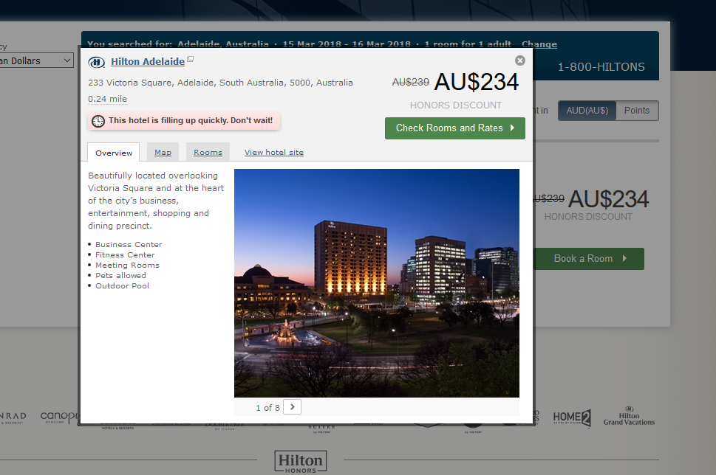

Figure Pop up overlay over the page

### Crowne Plaza Hotels & Resorts

Home page: <https://www.ihg.com/crowneplaza/hotels/us/en/reservation>

### Wyndham Hotel Group

Home page: <http://www.wyndhamap.com/wps/wcm/connect/Wyndham/home/Hotel-Group>

### Four Seasons

Home page: <https://www.fourseasons.com/>